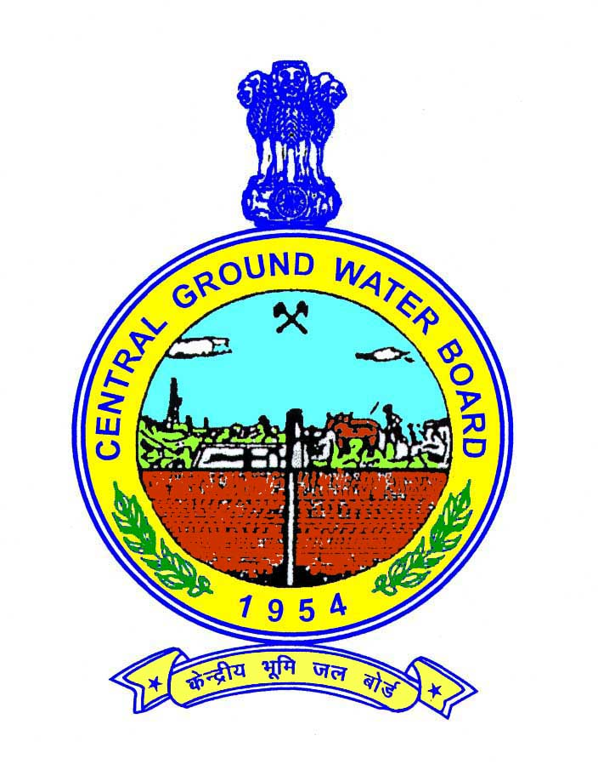

CENTRAL GROUND WATER BOARD
MINISTRY OF WATER RESOURCES, RIVER DEVELOPMENT AND GANGA REJUVENATION
GOVERNMENT OF INDIA

GROUNDWATER BROCHURE
DAUSA DISTRICT

RAJASTHAN

WESTERN REGION
JAIPUR
March 2017

DAUSA DISTRICT AT A GLANCE
1 | GENERAL INFORMATION
i | Geographical area (sq.km.) |  |  | 3420.17
ii | Adminisrative Divisions |  |  | 5 (Lalsot, Dausa, Bandikui, Sikrai, Mahuwa)
ii | No.of Tehsils |  |  | 5 (Lalsot, Dausa, Baswa, Sikrai, Mahuwa)
ii | No. of Blocks |  |  | 5 (Lalsot, Dausa, Bandikui, Sikrai, Mahuwa)
ii | No.of Villages |  |  | 1063  (Inhabited1027+uninhabited36)
ii | No. of Towns |  |  | 5 (Lalsot, Dausa, Bandikui, Sikrai, Mahuwa)
ii | Number of Municipalities |  |  | 3
iii | Population (as per 2011 census) |  |  | 16,37,226
iv | Average annual rainfall (mm)  (1977-2013) |  |  | 658.08
2 | GEOMORPHOLOGY
i | Major physiographical units |  |  | Fairly open undulating plain with hillocks in the south eastern border and in the northern part
ii | Major Drainage |  |  | Non-perennial Banganga and Morel rivers & their tributaries
3 | LAND USE (sq.km.)
i | Forest area |  |  | 166.6
ii | Net area sown |  |  | 2220.22
iii | Total Cropped Area |  |  | 3325.47
4 | MAJOR SOIL TYPES |  |  | Old alluvium  Lithosols and regosols of hills
5 | AREA UNDER PRINCIPAL CROPS  (sq.km.) (2008-09)
i | Food grains
 | Bajra |  |  | 1195.75
 | Wheat |  |  | 773.65
 | Barley |  |  | 84.67
 | Jowar |  |  | 60.89
 | Maize |  |  | 13.79
ii | Oil seeds |  |  | 1103.98
iii | Pulses |  |  | 72.28
iv | Others |  |  | 20.46
6 | IRRIGATION BY DIFFERENT SOURCES (2008-09)  (Area in sq.km.)
i | Dug wells/Tube wells/Bore wells |  |  |  | 1605.86
ii | Tanks/Ponds |  |  |  | Nil
iii | Canals |  |  |  | 7.29
iv | Other Sources |  |  |  | Nil
v | Net Irrigated Area |  |  |  | 1613.15
vi | Gross Irrigated Area |  |  |  | 1669.81
7 | NUMBER OF GROUND WATER MONITORING WELLS OF CGWB (2017)
i | No. of dug wells |  |  |  | 6
ii | No. of piezometers |  |  |  | 25
8 | PREDOMINANT GEOLOGICAL FORMATIONS |  |  |  | - Alluvium  - Formations of Delhi Super Group  - Formations of Bhilwara Super Group
9 | HYDROGEOLOGY
i | Principal Water Bearing Formations |  |  |  | Quaternary alluvium and talus & scree  (covering 84.65 % of district area)
i |  |  |  |  | Quartzite, phyllite/schist, gneiss of Bhilwara Super Group  (Covering 15.35% of district area)
ii | Pre-monsoon depth to water level during 2017 (mbgl) |  |  |  | 10.74 - 65.00  (20 to 40 m depth to water level is constituted by 43% of stations)
iii | Post-monsoon depth to water level during 2017 (mbgl) |  |  |  | 9.82 – 65.00  (20 to 40 m depth to water level is constituted by 33% of stations) & >40 M depth in 50% stations.
iv | Long term water level trend in last 10 years (2008-2017) m/year |  |  |  | 0.02 to 2.52 (decline)
10 | GROUND WATER EXPLORATION BY CGWB (as on 31.03.2017)
i | No. of wells drilled | Type of wells |  |  | Formation |  |  |  | Total
i | No. of wells drilled |  |  |  | Uncon. | Con. |  |  | Total
i | No. of wells drilled | EW |  |  | 33 | 13 |  |  | 46
i | No. of wells drilled | OW |  |  | 4 | 1 |  |  | 5
i | No. of wells drilled | SH |  |  | 3 | - |  |  | 3
i | No. of wells drilled | PZ |  |  | 16 | 3 |  |  | 19
ii | Depth Range (m) |  |  |  | Uncon. |  |  | Con.
ii |  |  |  |  | 19 - 85 |  |  | 74 - 203
iii | Discharge (lpm) |  |  |  | 150 - 1000 |  |  | < 50 – 400
iv | Transmissivity (m² /day) |  |  |  | 40 - 1688 |  |  | --
v | Storativity |  |  |  | 5.5x10⁻⁴ – 3.7x10⁻³ |  |  | --
11 | GROUND WATER QUALITY
i | Presence of chemical constituents more than permissible limit |  | EC  (mS/cm at 25⁰C) |  |  |  | 600 - 5950
i |  |  | F  (mg/l) |  |  |  | 0.2 – 8.2
i |  |  | Fe  (mg/l) |  |  |  | 0.02 – 5.1
 |  |  | NO₃  ( mg/l) |  |  |  | 2 - 650
ii | Type of water |  |  |  |  |  | Alkaline
12 | DYNAMIC GROUND WATER RESOURCES (as on 31.03.2013)  (Figures in mcm)
a. | Potential zone area |  |  |  | 3085.62
b. | Net annual ground water availability |  |  |  | 254.3359
c. | Existing gross ground water draft for irrigation |  |  |  | 390.2294
d. | Existing gross ground water draft for domestic and industrial use |  |  |  | 29.0612
e. | Existing gross ground water draft for all uses |  |  |  | 415.7716
f. | Net ground water availability for future irrigation development |  |  |  | 0.00
g. | Stage of ground water development |  |  |  | 168.05
13 | CATEGORY OF BLOCKS
 | All five blocks (Lalsot, Dausa, Bandikui, Sikrai, Mahuwa) over-exploited
14 | GROUND WATER VULNERABLE AREAS
i | Deep water level
ii | Declining ground water level
iii | Ground water salinity
iv | Fluoride hazard
12 | Mass awareness Programme (MAP)
i | A Mass Awareness Programme on “Village level Aquifer Managment” was organized at Dausa Town, Dausa district on 27th-28th February 2013.
ii | Again in 2014 a Mass Awareness programme on "Aquifer Management Through Participatory Approach & Local Ground Water Issues" have been organized at Bandikui, Dausa from 18.2.2014 to 19.2.2014.

GROUND WATER BROCHURE

DAUSA DISTRICT
1.0 INTRODUCTION
Dausa district is located in the eastern part of Rajasthan State and lies between 26°22'40" & 27º14'00" north latitudes and 76°08'30" & 77°02'15" east longitudes. It covers 3420.17sq.km of geographical area (Fig.1). The administrative set up of the district is given below.
SI.No | Sub-division | Tehsil | Block | Area (sq.km.)
1 | Lalsot | Lalsot | Lalsot | 871.24
2 | Dausa | Dausa | Dausa | 943.76
3 | Bandikui | Baswa | Bandikui | 632.64
4 | Sikrai | Sikrai | Sikrai | 502.23
5 | Mahuwa | Mahuwa | Mahuwa | 470.00

The population of district is 16,37,226 based on Census, 2011 including 8,59,821 (52.51%) males and 7,77,405 (47.48%) females. The density of population is 476 persons/sq.km.
Dausa district is covered under mainly Banganga basin, (forming 62.89% part in upper northern part of district), Morel basin (34.27% part occupying southern part of district) and very small part by Ghambhir basin (encompassing 2.84% part in south of Mahuwa). Surface water divide runs from south of Bhandana to Paparda in the southern part of Dausa block and separates the district into two river basins viz. Banganga and Morel river basins (Fig.2).
The area is drained by Banganga and Morel rivers, which are nonperennial in nature and flow during monsoon period only. The drainage is dendritic type. The drainage density ranges from 0.50 to 0.70 km/km² (Karanth, 1980).

The land use statistics of the district is furnished below.
SI.No. | Particulars | (Figures in sq.km.)
1 | Area not suitable for cultivation | 555.09
2 | Hills & hilly forest | 199.93
3 | Pasture land | 65.10
4 | Barren land | 84.53
5 | Others | 38.93
6 | Area suitable for cultivation but not Cultivated | 528.25
7 | Area under cultivation | 2336.83
i | Area irrigated by wells | 1739.87
ii | Area irrigated by canals | NIL
iii | Area irrigated by tanks/ponds | NIL
iv | Area irrigated by other sources | NIL
v | Unirrigated area | 596.96

Agriculture activity is spread over both kharif and Rabi cultivation. Kharif cultivation is rainfed and Rabi cultivation is ground water based. The main kharif crops grown in the area are Bajra, Maize, Groundnut and Moth where as principal Rabi crops are Wheat, Barley, Gram, and Mustard etc.

The total sown area is 2336.83 sq.km, out of which 1739.87 sq.km (forming 74.45 %) is irrigated.

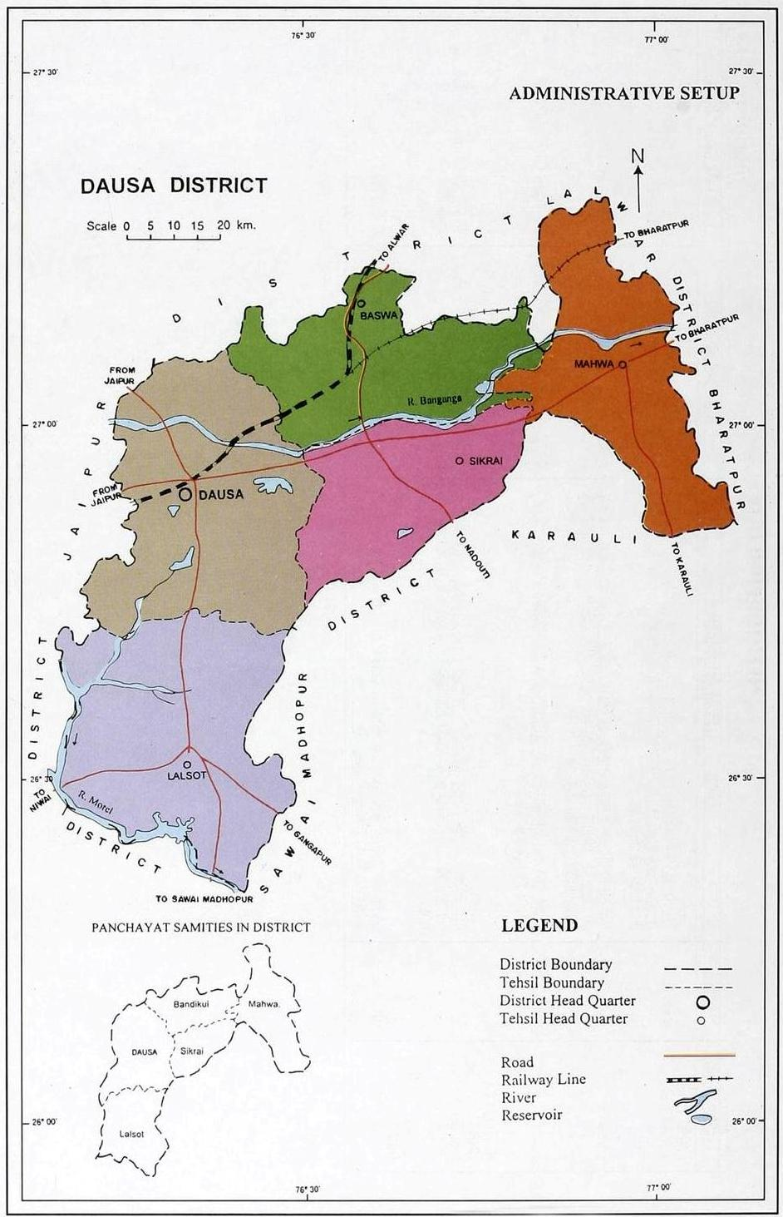
Fig 1: Index Map
The district has been covered under systematic hydrogeological survey by 1979. Detailed hydrogeological studies, geophysical studies, ground water exploration, resource estimation etc. were under taken during 1976-80 in Banganga river basin by CGWB. Similar studies were also carried out in Morel river basin during 1978-82. Area has been covered under reappraisal hydrogeological survey during 1987-88. Further exploratory drilling was carried out during 1987-88 and continued till March 2007 including construction of piezometers. District hydrogeological report of Dausa district has been compiled and issued in the year 1988 and revised and issued in 1994.Hydrograph stations are being monitored four times a year since 1969.

2.0 RAINFALL AND CLIMATE
The climate of the district can be classified as semi-arid. It is charaterised by very hot summers and very cold winters with fairly good rainfall during southwest monsoon period. In May and June, the maximum temperature may sometimes go up to 48°C. The potential evapotranspiration rates are quite high, especially during May and June.
The mean annual rainfall of the district based on 37 years data (1977-2013) works out to be 658.08mm. The coefficient of variation is moderate at 34.1% indicating that the rainfall is slightly unreliable and droughts occur in continuous spells of few years. The district experienced very poor rainfall continuously for a period of six years i.e. from 1986 to 1991. The area again experienced drought conditions from 1999 to 2002. The year 2002 was the worst year with rainfall being 53.2% less than mean annual rainfall. The period between 1992 and 1998 was exceptionally good with rainfall in excess of mean rainfall for 7 consecutive years. The rainfall in the year 1995 was 91.5% more than mean annual rainfall.

3.0 GEOMORPHOLOGY AND SOIL TYPES
The district forms part of East Rajasthan upland. It consists of fairly open undulating plain with hillocks in the southeastern border and in the northern part. The altitude of relief ranges
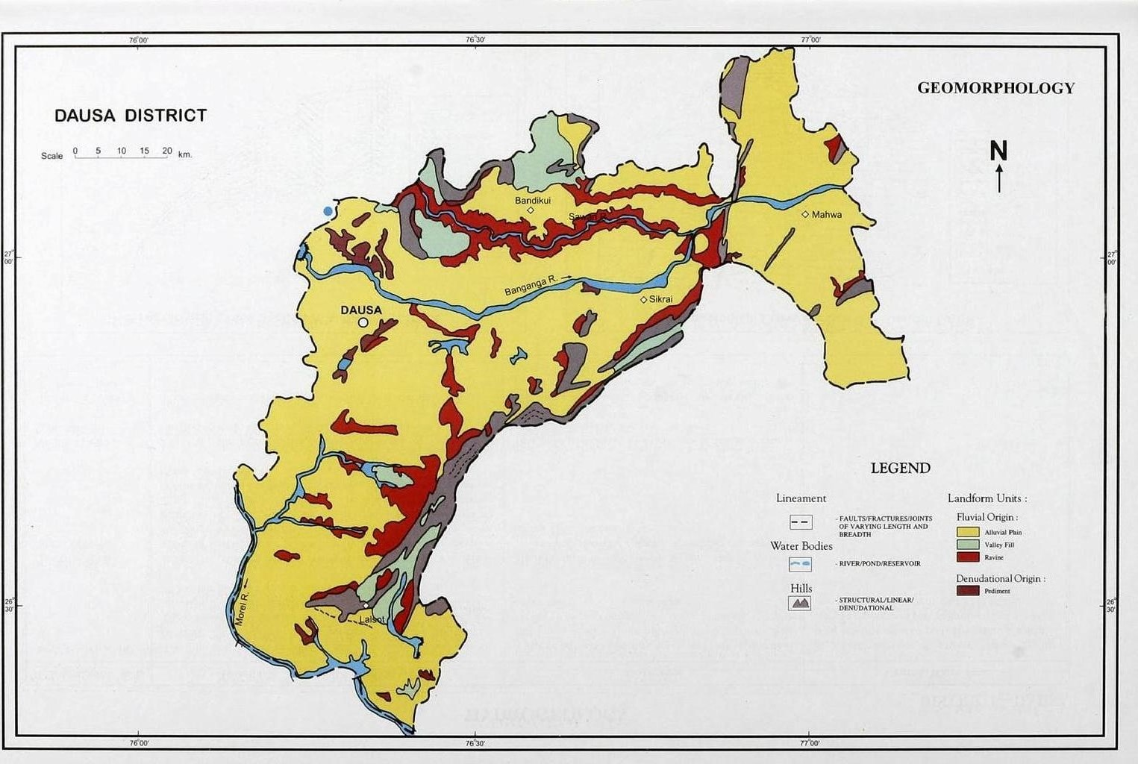
Fig 2: Geomorphological Map of Dausa District.

from 280 to 334 m amsl in the northern part of the district with west to east slope and from 250 to 273 m amsl in the southern
part with northwest to south east slope. The only hill forming part of Aravalli hill system in the area is the Lalsot -Toda Bhim having a relative height of over 200 m. The various geomorphological units developed by ways of different origin are furnished below.

 | Origin |  | Land Form Unit | Occurance
i | Structural | i | Ridges and Valleys | Confined to hilly terrain mostly lies on the south eastern margin of the district and scattered isolatedly in northern part
ii | Fluvial | i | Alluvial Plain | Major portion of the district is characterized by undulating plains which are big & large monotonous land scape with fairly thick alluvial cover
ii | Fluvial | ii | Bad Lands (Ravines) | Occur in the form of longitudinal track  in the northern part of the district and in isolated pockets in the east of Dausa.
iii | Aeolian | i | Zones of Barchan dunes | Northern part of district in west of Bandikui
iii | Aeolian | ii | Zones of obstacle dunes | All along west of hill ranges trending in NE -SW direction in the southeastern border of the district.
iii | Aeolian | iii | Sand Sheet | Southern part of the district.
iv | Denudational | i | Plantation of surfaces on proterozoic rocks | On the proterozoic rocks between Lalsot and Paparda
iv | Denudational | ii | Piedmont zones | In foothills at two places i.e. east of Lalsot and between Kalakhoh and  Denda along the extreme south east periphery of district.

The area has two types of soils viz. old alluvium and lithosols and regosols of hills. Old alluvium soil occupies major part of the area and found in plains. They are calcareous semi-consolidated to unconsolidated brown soils, loamy sand to sandy loam in texture. These are well drained. Lithosols and regosols of hills is present in north western part and in south eastern border and found on Bhilwara's, Delhi's meta sediments and in isolated hills. These soils are shallow with gravel very near the surface, light textured, fairly drained, reddish brown to greyish brown in colour. Cultivation is restricted because of a limited root zone.

4.0 GROUND WATER SCENARIO
4.1 Hydrogeology
Quaternary alluvium is the principal water bearing formation occupy more than 3/4th part of the district. Talus & scree deposits and hard rocks of Bhilwara and Delhi Super Group rest in small part (forming 15.35% of district) forming minor aquifers in the district (Fig.3).

Alluvium (composed of sand, clay, kankar and gravel) forms the principal and potential aquifer in the area. Ground water
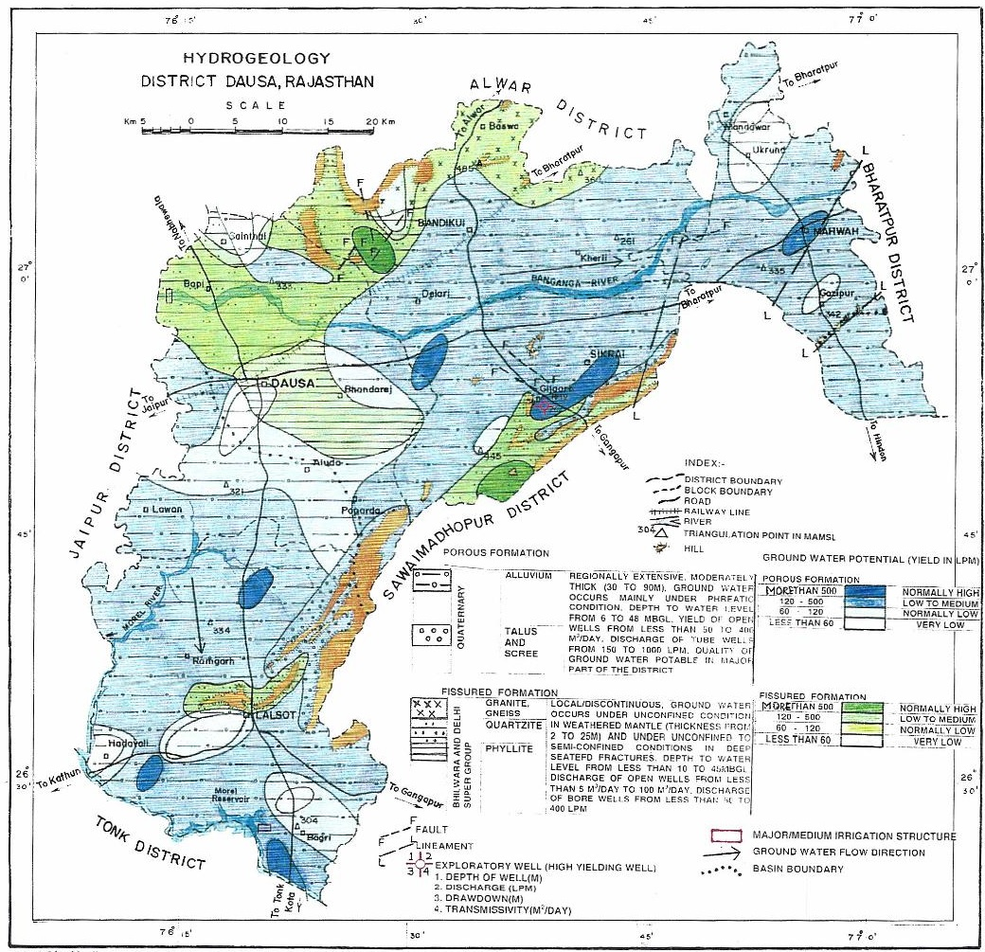 Fig 3: Hydrogeology Map of Dausa District.
Occurs under unconfined to confined conditions in the primary porosity i.e. pore spaces. Exploratory borehole data has revealed the presence of aquifer system down to the depth of 90 m reaching maximum in the Mahuwa block.

Talus and scree deposits form minor aquifer occuring on the flanks of almost all the hills. Lithologically, these are composed of rock fragments. Topographically, these are situated in such a position that they receive all the run-off from the hills/hill ranges located nearby. Width of talus and scree deposits along the foothills varies from a few metres to over 500 m. It is more where hill ranges are tectonically affected and disrupted by faulting. Ground water occurs under unconfined to semi-confined conditions. They form locally very potential aquifer along foothills in the area towards north east of Lalsot along Lalsot-Todabhim fault zone. Thickness of talus and scree deposits goes up to 50 m of which the aquifer comprises 28 to 50 m.

Quartzite, phyllite/shale, gneisses of Bhilwara Super Group form the minor aquifers and occupy the north western part and south eastern border of the district. Ground water occurs under unconfined condition to semi-confined conditions in the weathered mantle (ranging in thickness from 2 to 25 m) and deep-seated secondary porosity i.e. fractures, joints, contacts etc. of hard formation.

The total number of hydrograph stations in the district is 31 including 6-dug wells and 25 peizometers. Depth to water level varies from 10.74 m to 65.00 m during pre-monsoon, 2017 (Fig.4) and 9.82 m to 65.00 m during post-monsoon, 2017 (Fig5). Deeper water level i.e. more than 30 m has been observed in area around Bandikui, Baswa (Bandikui block), Mandawar (Mahuwa block) and Lalsot (Lalsot block). Out of total stations monitored, about 33% of stations exhibit water level between 20 and 40 m, 50% stations have more than 40 m water level and less than 20 m water level is constituted by only 17% of stations. Amplitude of negative fluctuation ranges from less than 1 m to 2m. Positive fluctuation has been observed in major areas covering major part of Mahuwa block and areas around Dausa & west of Dausa, Baswa, southeast part of lalsot block and at local pockets.

The Study of long-term water level trend for the last ten years (premonsoon, 2008 -2017) reveals that all the hydrograph stations exhibit declining trend ranging from 0.02 to 2.52m/year.

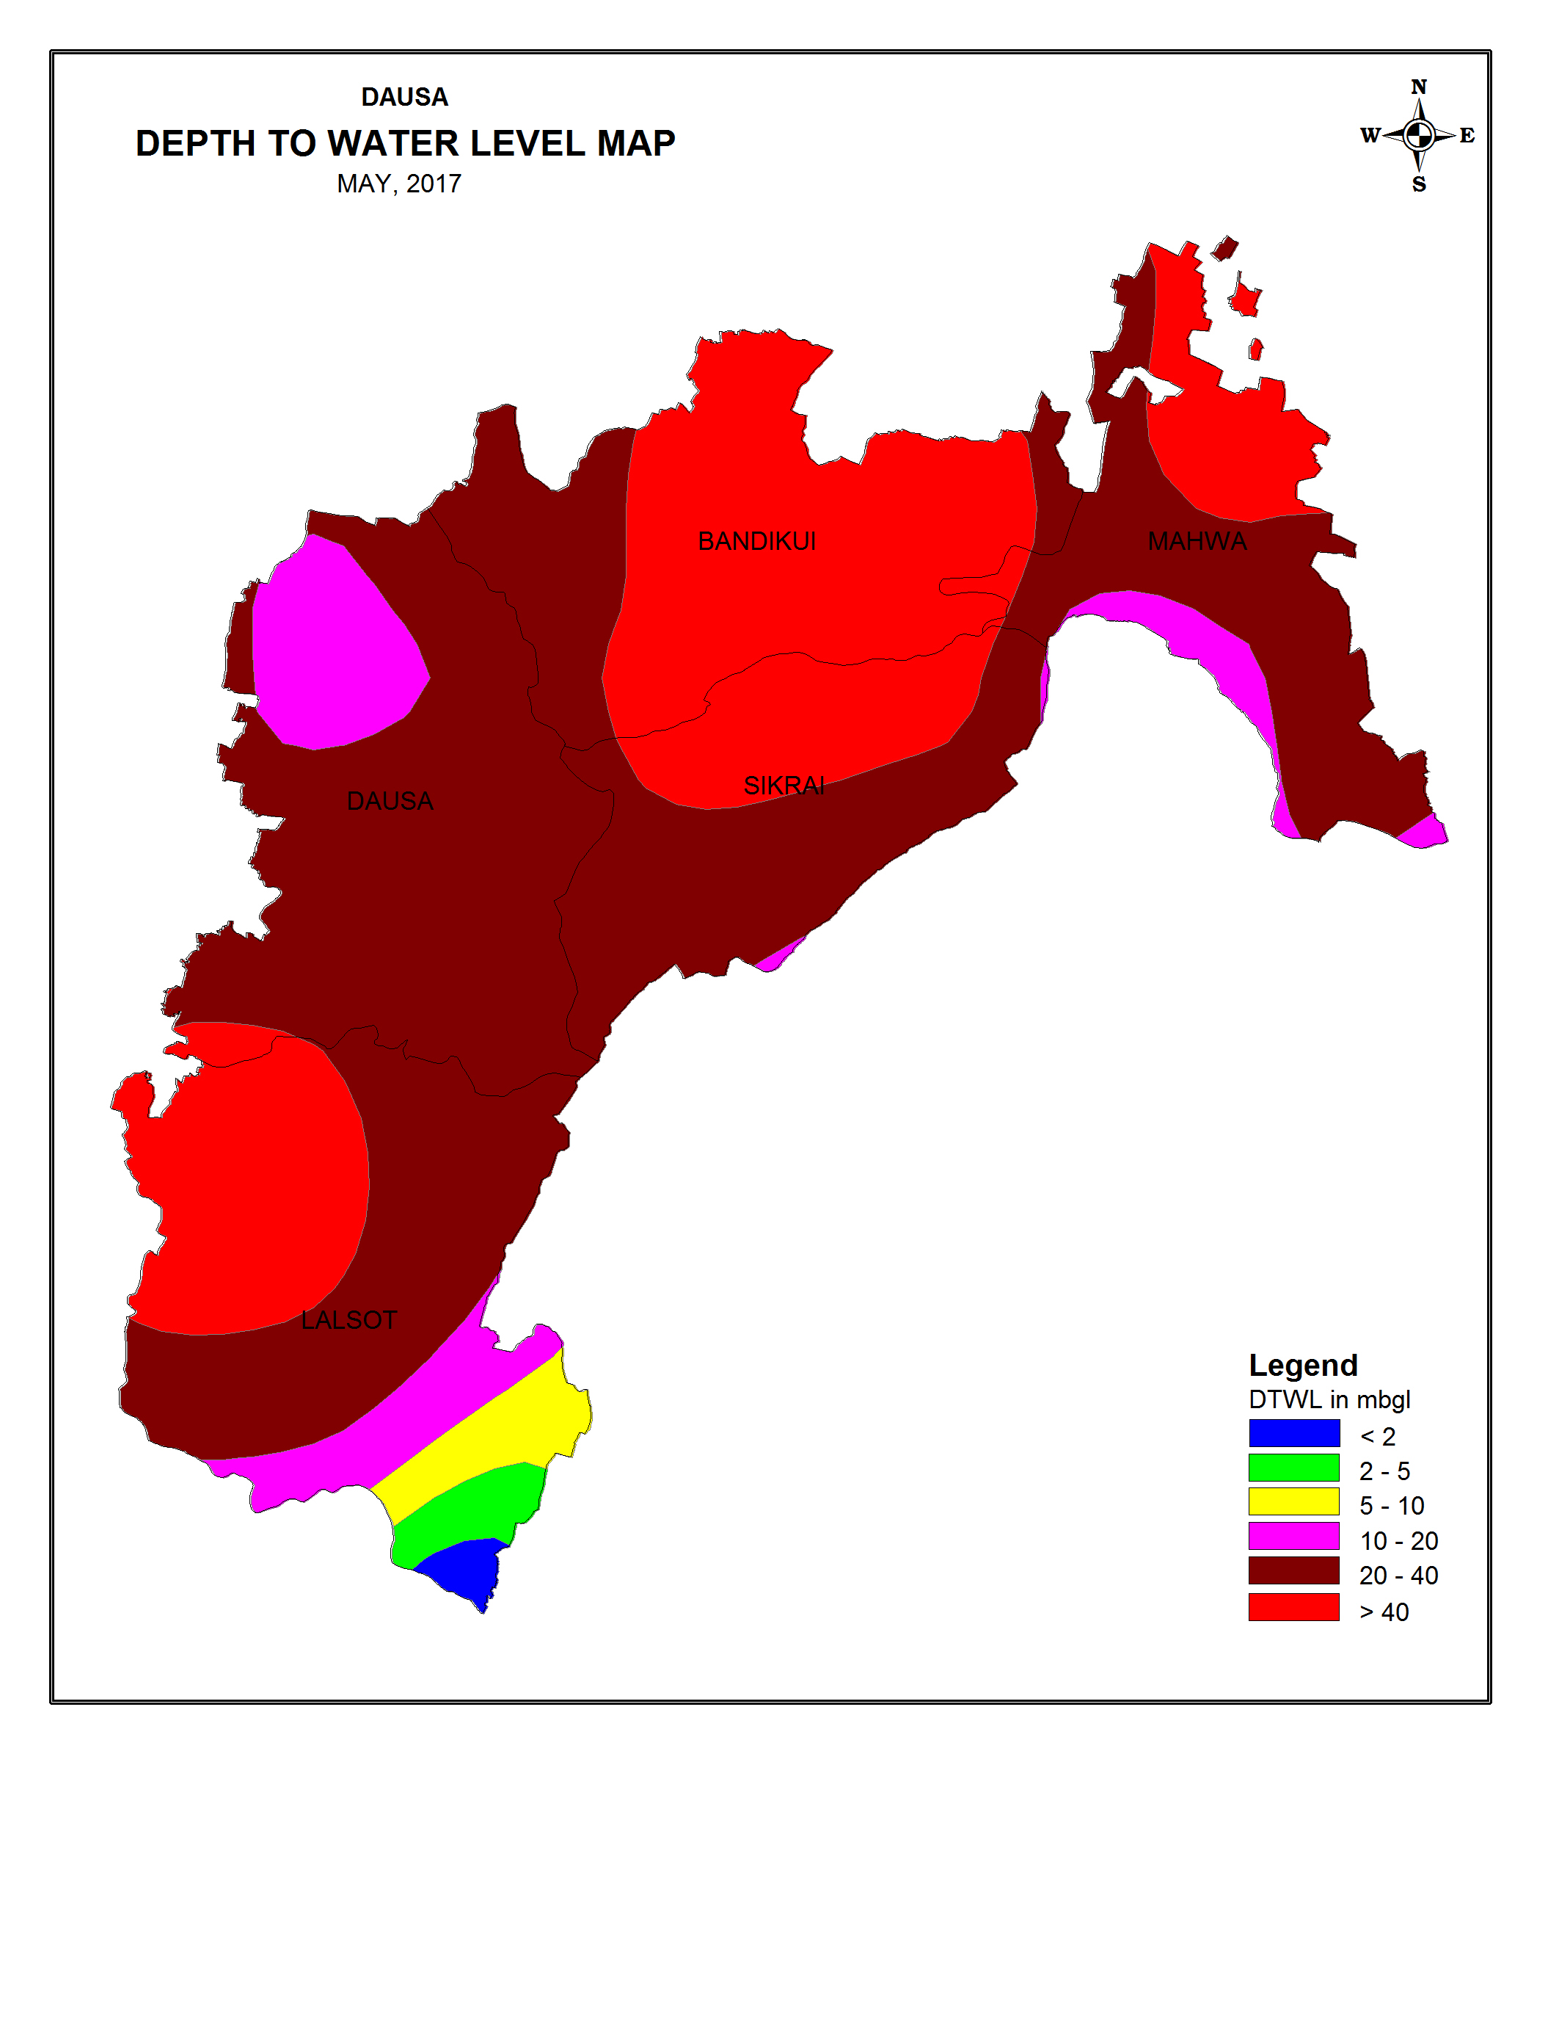
Fig 4: Pre-Monsoon depth to water level map of Dausa district.
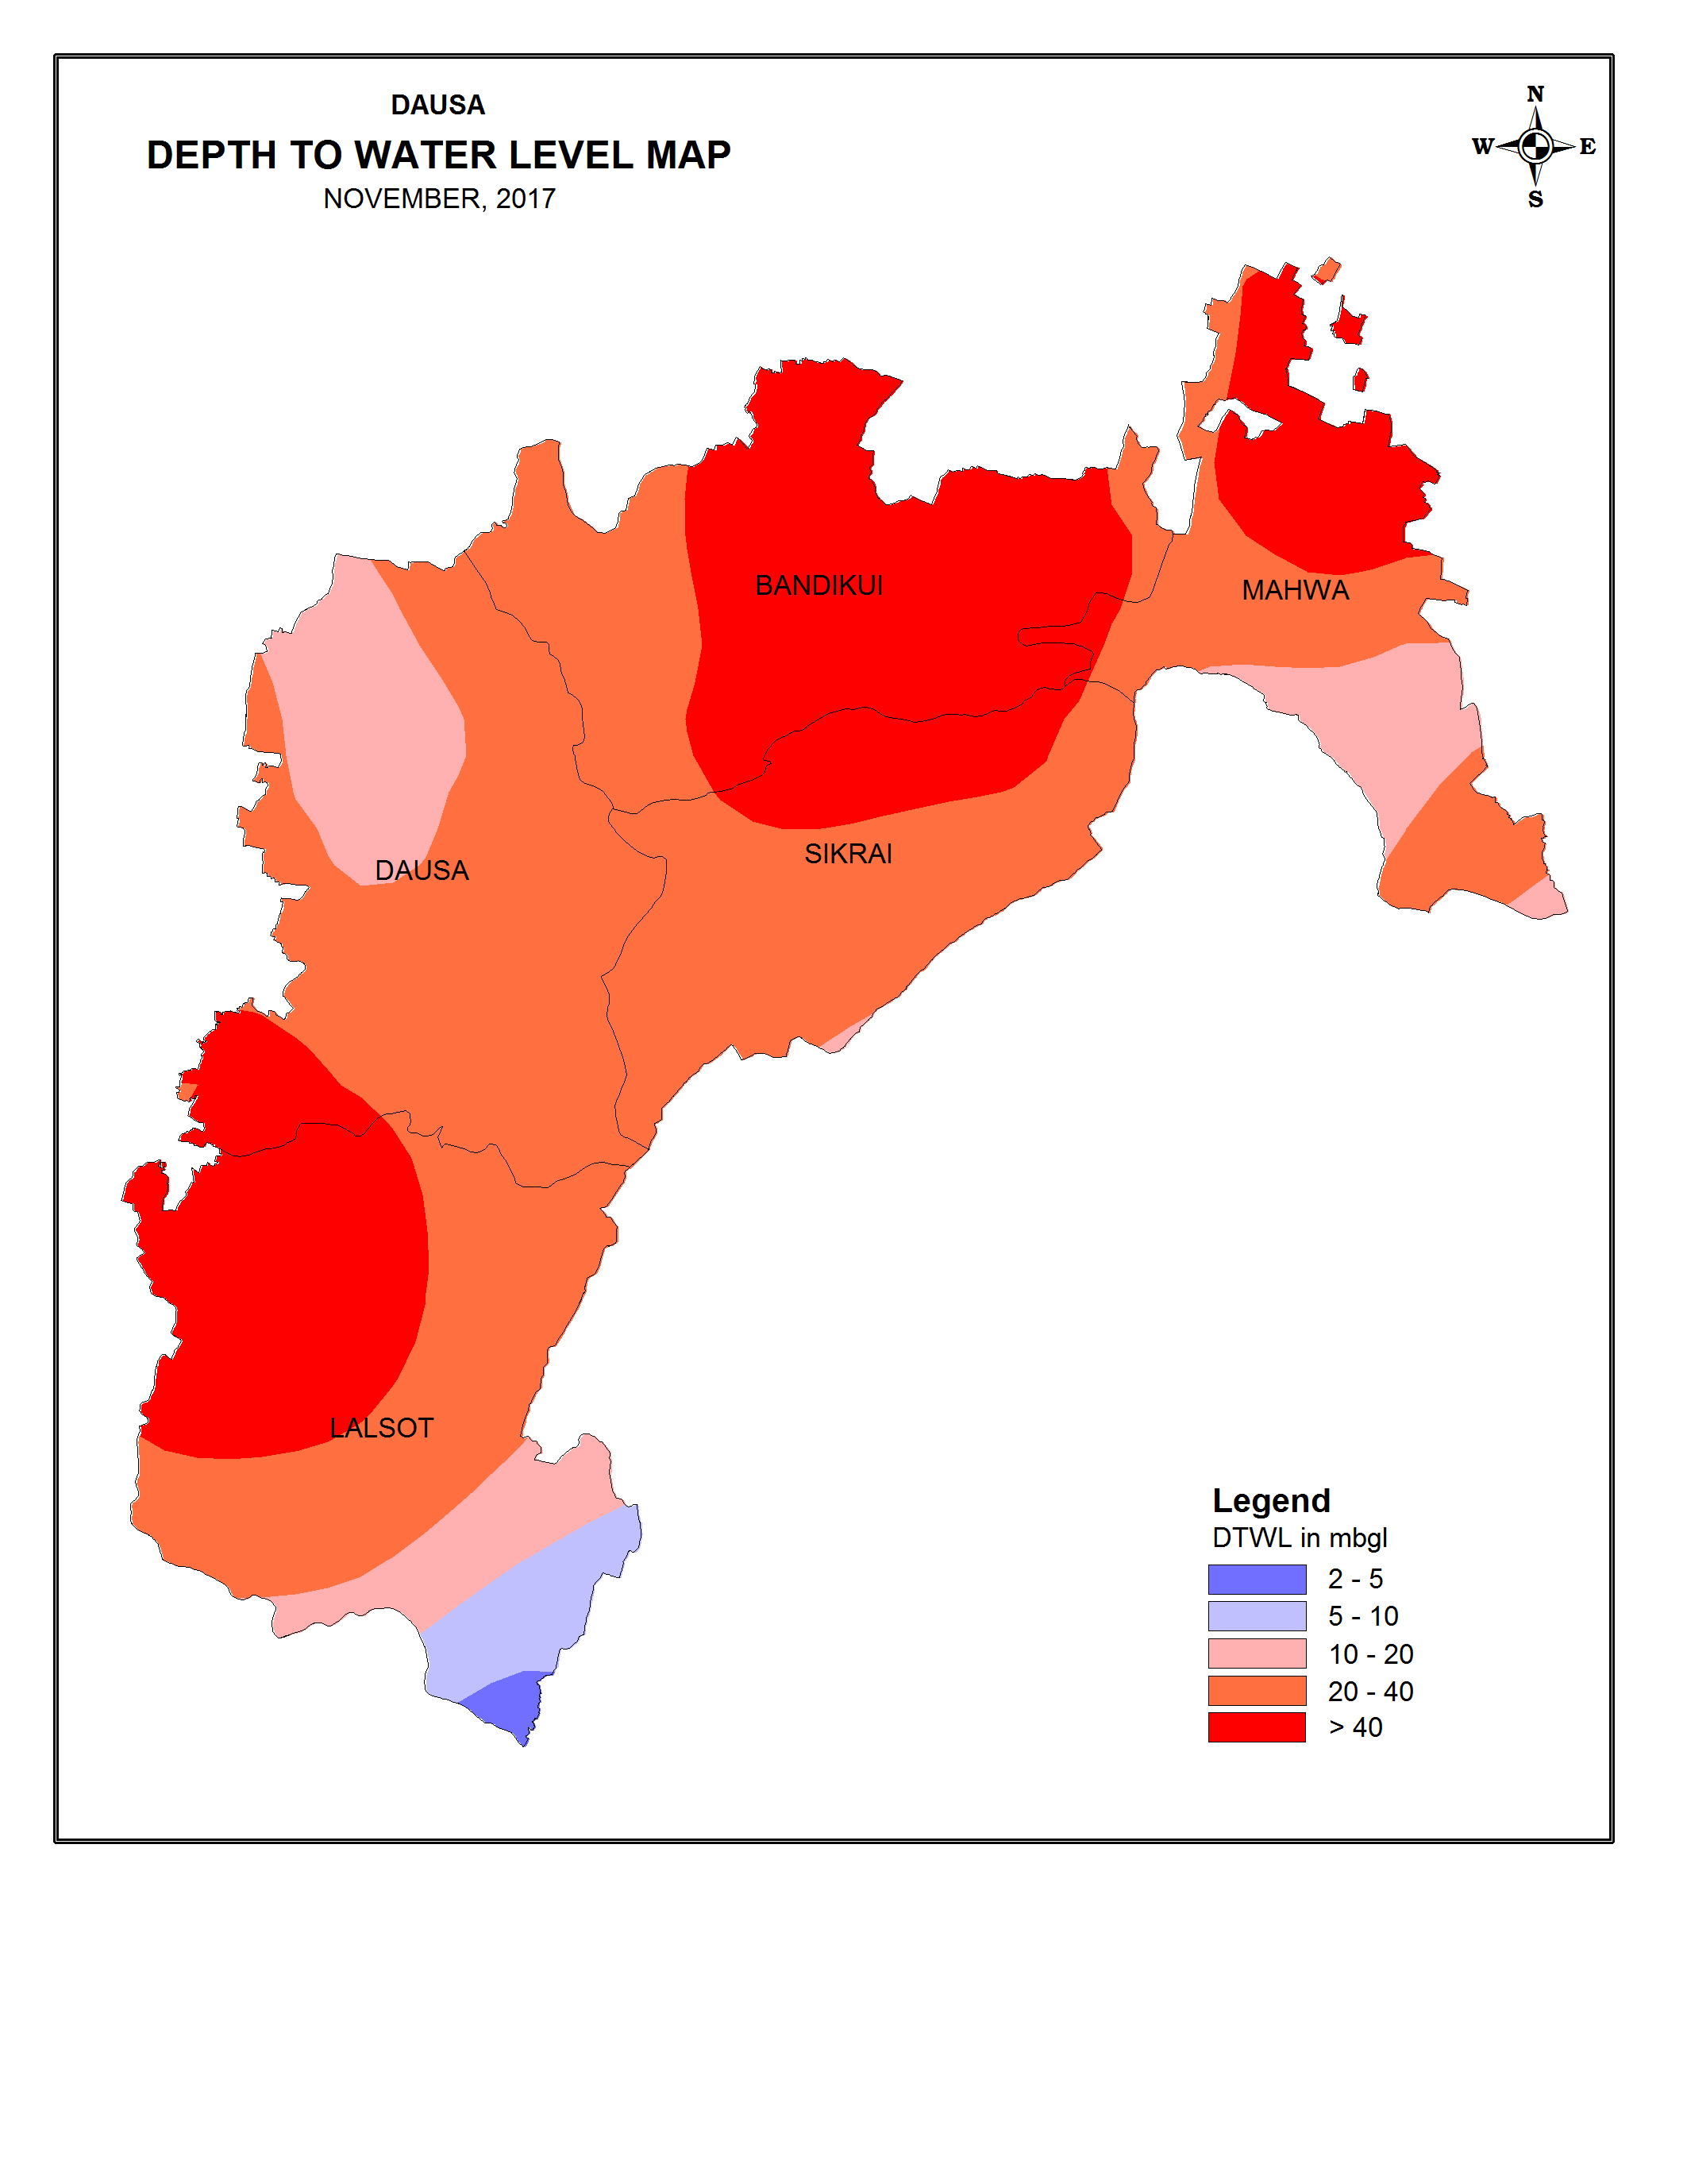
Fig 5: Post-Monsoon depth to water level map of Dausa district

The yield of open wells tapping alluvial formation and talus and scree deposits varies from less than 30 to 400 m³/day depending upon the locations. The specific capacity of wells based on Slitcher's formula ranges from 0.0031 to 0.0443 m³/m/m and optimum yield lies between 2 and 80 Ipm. The yield of open wells in hard rocks ranges from less than 5 to 100 m³/day averaging to about 30 m³/day. The specific capacity of wells ranges from 0.0205 to 0.0086 m³/m/m and optimum yield is about 36 Ipm.

The status of boreholes (as on 31.03.2014) drilled by CGWB is presented below.

Type of wells | Formation |  | Total
Type of wells | Alluvium | Hard rock | Total
Exploratory well (EW) | 25 | 13 | 38
Observation well (OW) | 3 | 1 | 4
Slim hole (SH) | 3 | - | 3
Piezometer (PZ) | 16 | 3 | 19

Exploratory borehole data drilled in alluvial formation has indicated that depth of drilling ranges from 28.59 to 86.16 m and depth of wells constructed varies from 18.98 to 85.11 m. The discharge of wells varies from 60 to 1000 Ipm having 2 to 28 m of drawdown. The transmissivity value of aquifer varies from 1.22 to 1688 m²/day and storativity from 5.5x10⁻⁴ to 3.7x10⁻³. The specific yield of alluvium ranges from 0.08% to 0.12%.

In hard rock, the depth of bore wells drilled varies from 74 and 203.7 m having discharge from less than 50 to 400 Ipm with moderate drawdown. The formations encountered are granite, gneiss of Bhilwara Super Group and quartzite, slate, phyllite of Delhi Super Group.
The discharge of exploratory wells are statistically analysed and furnished below.
Total No. Of Wells Analysed | Range of discharge in lpm
Total No. Of Wells Analysed | <60 |  | 60-120 |  | 120-500 |  | >500
Total No. Of Wells Analysed | No. | % | No. | % | No. | % | No. | %
61 | 15 | 24 | 4 | 6 | 27 | 46 | 15 | 24

4.2 Ground Water Quality
The ground water is moderately alkaline type having pH value more than 7 and is potable in major part of the district. The electrical conductivity in general rests between 600 to 5950 μS/cm at 25ºC in major part of the area (Fig.6), however it ranges from 600 (minimum at garh ranoli in sikrai block and kali pahari in dausa block) to 5950 μS/cm at 25°C (maximum at Bapi in Dausa block). Out of total stations, 69% of stations have electrical conductivity within 3000 μS/cm at 25°C. EC value between 2000 and 3000 is constituted by 25% of the samples and 31% of stations rests beyond 3000 μS/cm at 25°C occupying which covers the central part of Dausa block, west of Mahuwa, west of Sikrai and south west of Lalsot.

Nitrate concentration falls within permissible limit i.e.45 ppm in greater part of the area constituted by 81.25% of stations (Fig.6). Fluoride content ranges from traces to a maximum of 3.60 mg/I Out of total stations18.75% of stations represent fluoride concentration more than permissible limit i.e.1.5 mg/I (Fig.6).

Iron concentration ranges from nil (at bapi and bhandarej in dausa block) to a maximum of 5.80 mg/I (at baswa in bandikui block). Out of total stations, >50% of stations have iron content beyond permissible limit i.e 0.3 mg/I of drinking water standard (Fig.6).

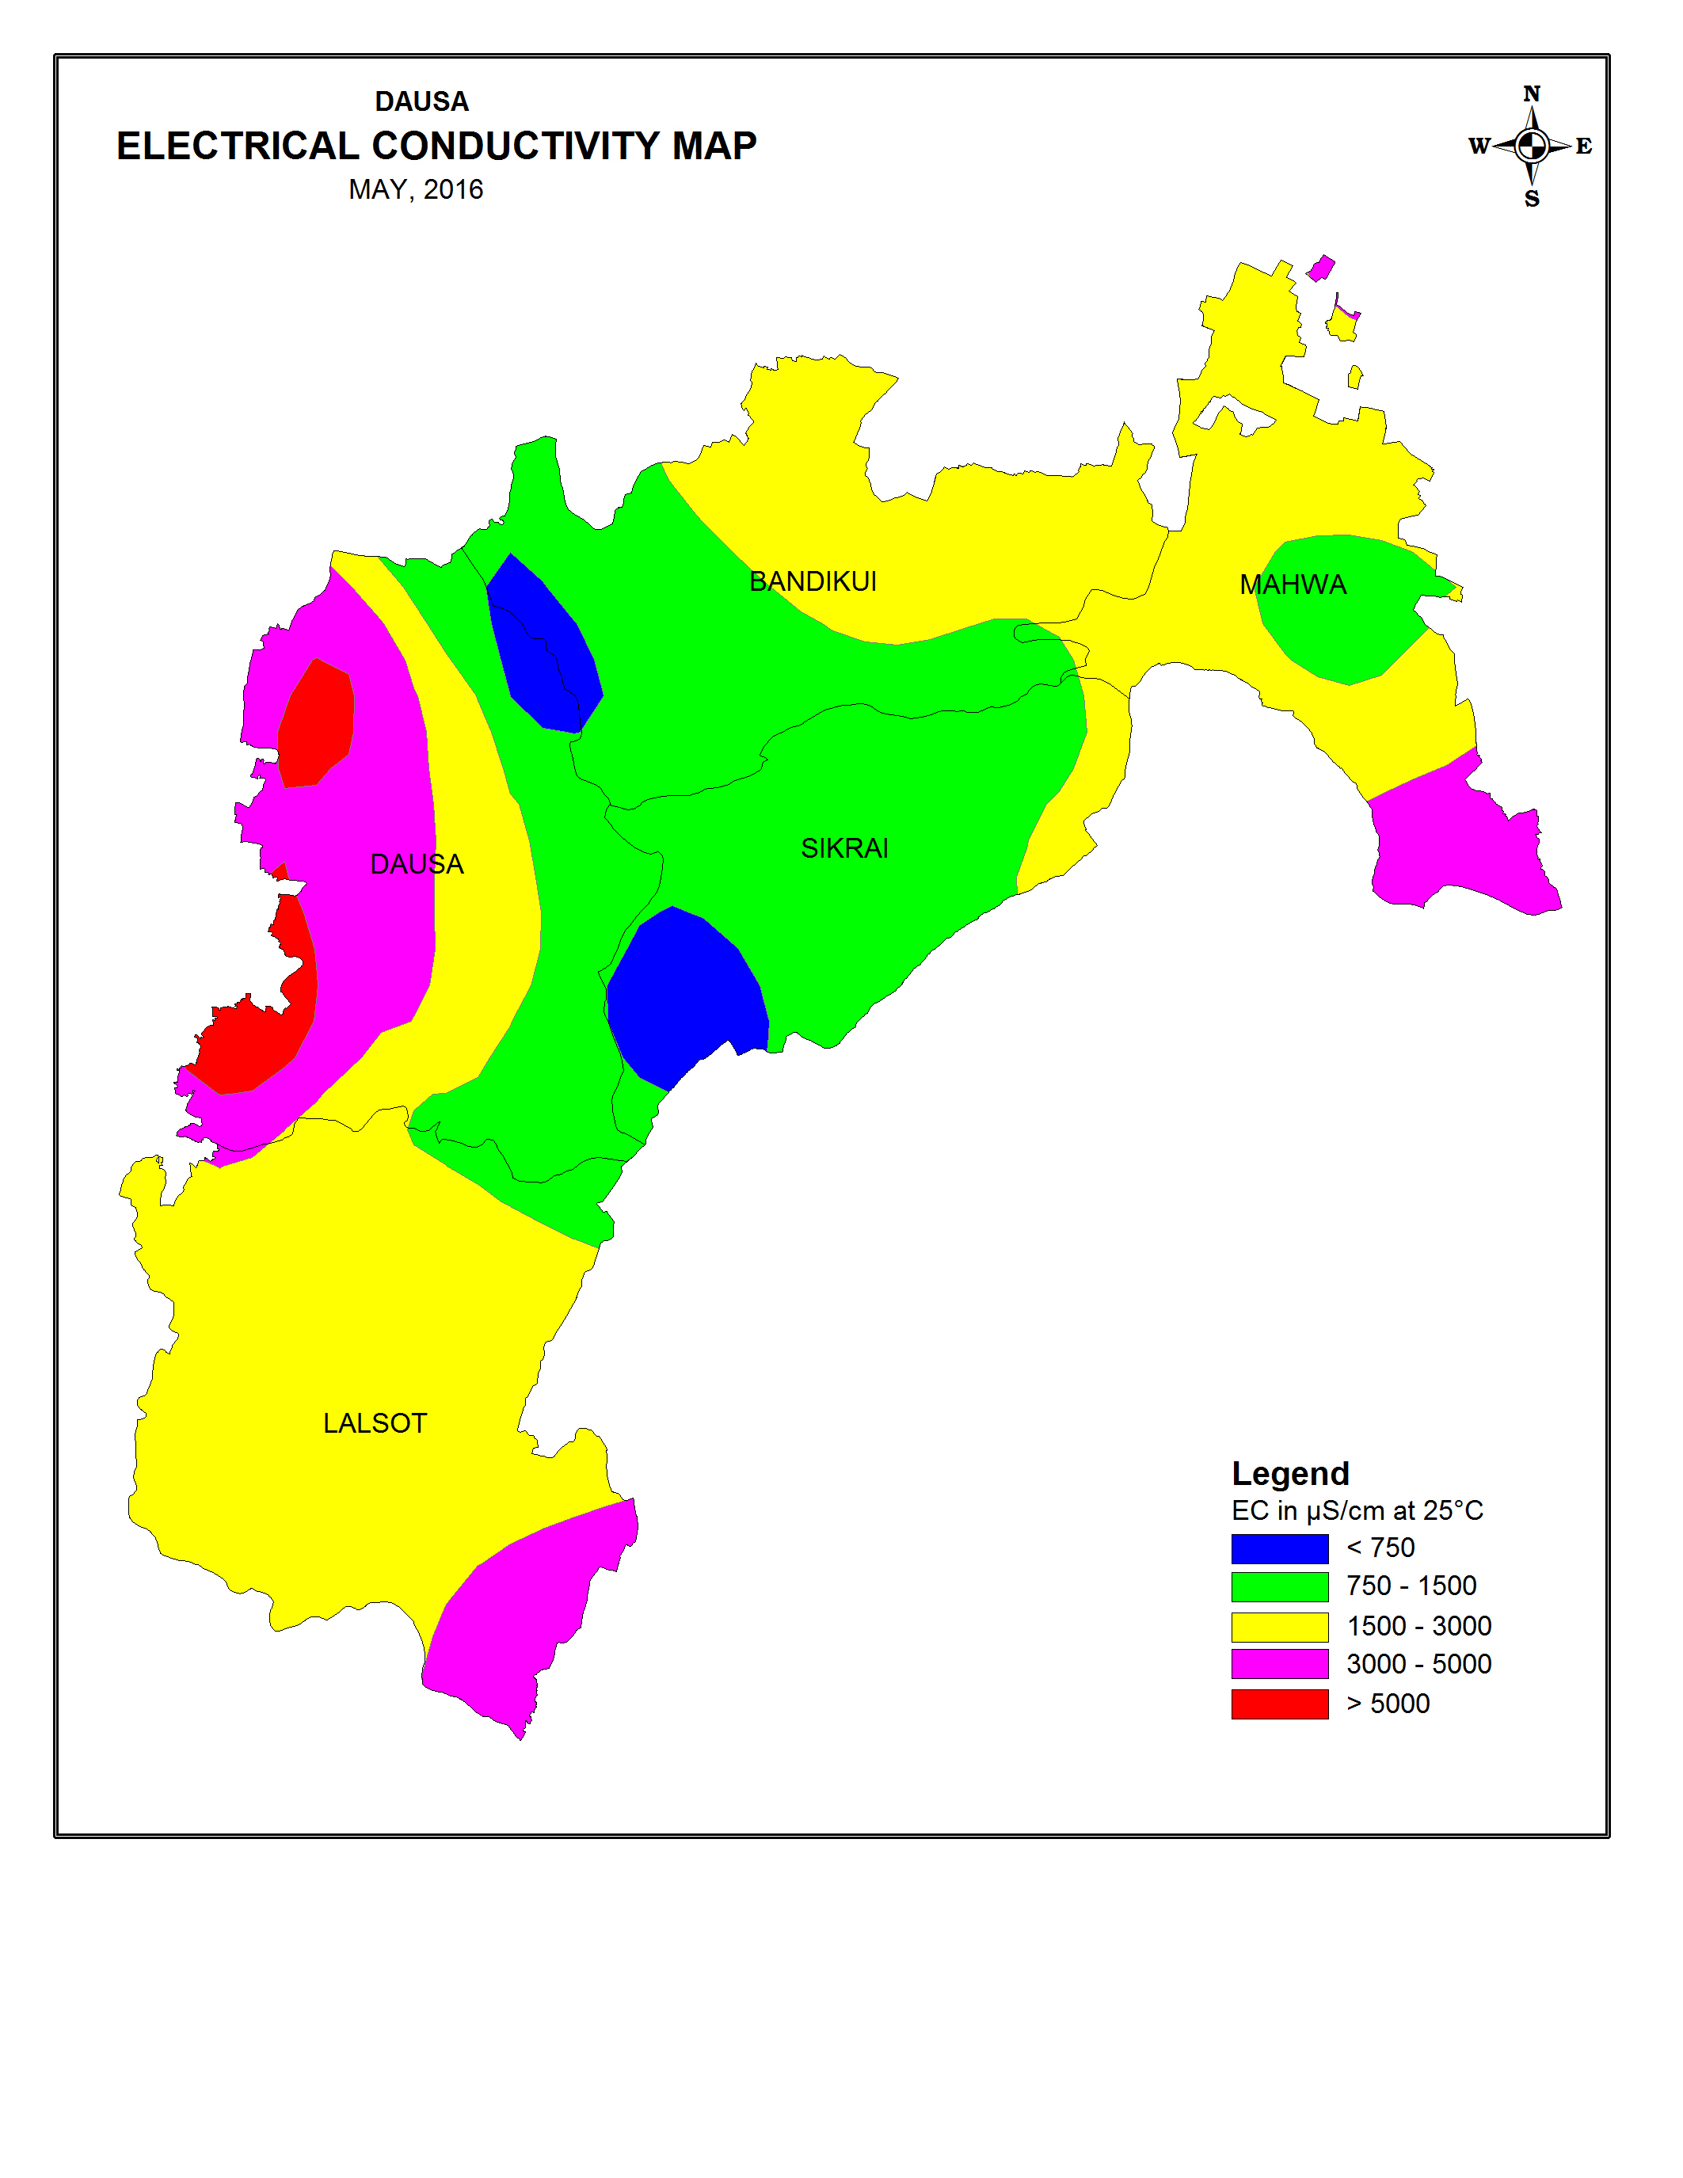
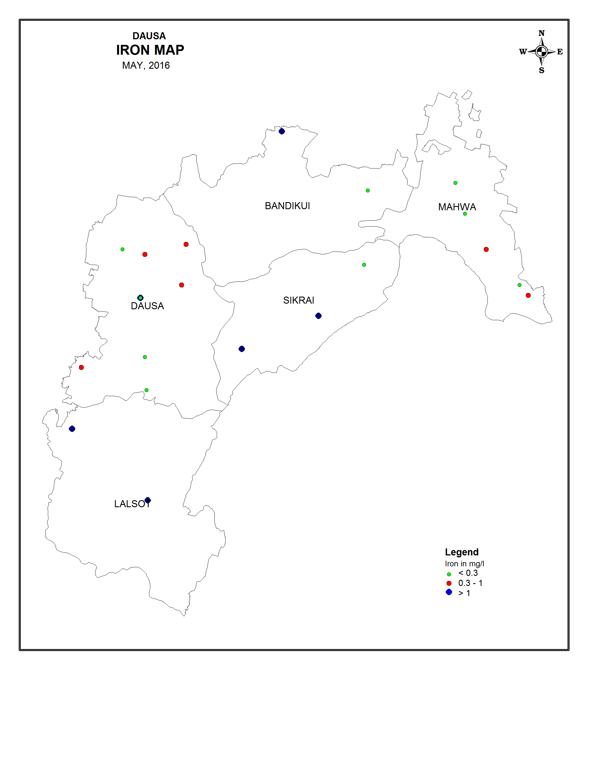 | 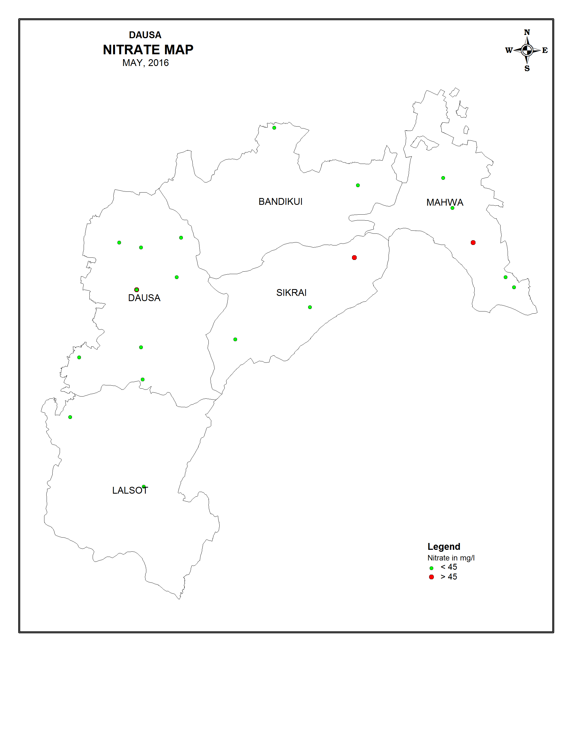
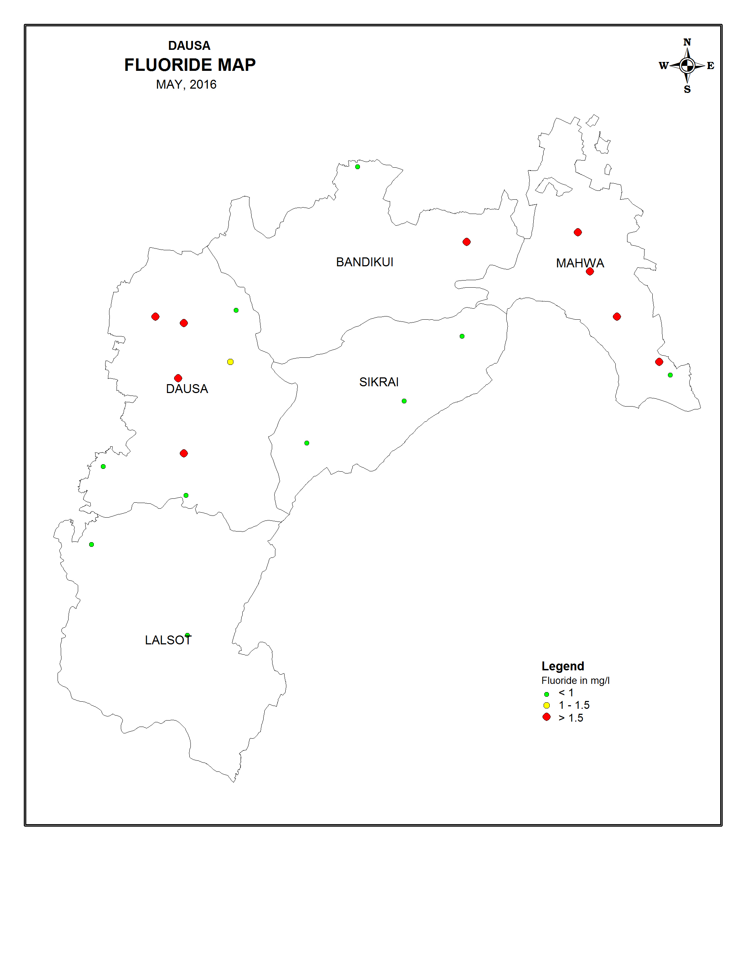

Fig 6: Groundwater Quality map of Dausa District.

4.3 Ground Water Resources
The dynamic groundwater resources (Fig.7) as per ground water estimation as on 31.03.2013 is furnished below.
Block | Area Of Block (sq km) | Type of Area | Potential Zone (sq km) | Net Annual GW Availability (mcm) | Exisiting Gross GW Draft for Irrigation (mcm) | Exisiting Gross GW Draft for Dom. & Industrial use (mcm) | Exisiting Gross GW Draft for all uses (mcm) | Net GW Availability for future Irrigation development (mcm) | Stage of Development (%) | Category
1 | 2 | 3 | 4 | 5 | 6 | 7 | 8 | 9 | 10 | 11
Bandikui | 632.94 | NC | 528.9 | 34.8283 | 72.3347 | 4.7453 | 76.40 | 0.0 | 219.37 | O.E
Dausa | 943.76 | NC | 894.74 | 68.3923 | 70.6314 | 10.8039 | 79.93 | 0.0 | 116.87 | O.E
Lalsot | 871.24 | NC | 780.36 | 60.6702 | 121.3560 | 3.1670 | 124.64 | 0.0 | 205.44 | O.E
Mahua | 470 | NC | 442.0 | 34.1292 | 46.6905 | 5.3420 | 51.30 | 0.0 | 150.33 | O.E
Sikrai | 502.23 | NC | 439.62 | 56.3159 | 79.2168 | 5.0030 | 83.49 | 0.0 | 148.25 | O.E
Total of District | 3420.17 |  | 3085.62 | 254.3359 | 390.2294 | 29.0612 | 415.76 | 0.0 | 168.05 | O.E

The entire area falls under non-command and all the blocks fall under over-exploited category due to excessive use of ground water being the only source of irrigation.

5.0 GROUND WATER RELATED ISSUES AND PROBLEMS
5.1 Declining water level
Long-term water level data (pre-monsoon, 2008-2017) have indicated declining trend ranging from 0.02 to 2.52m/year. As a result of which all the blocks have entered into the over-exploited category.

5.2 Ground water salinity
31% of stations rest beyond 3000 micromhos/cm at 25°C occupying which covers the central part of Dausa block, west of Mahuwa, west of Sikrai and south west of Lalsot.

5.3 Fluoride hazard
The range of the fluoride found in the collected water samples in the district is 0.25 to 3.6 mg/l, out of which, 31.25% of stations represent fluorid concentration more than permissible limit i.e.1.5 mg/I.

5.4 Nitrate Hazard
The range for the nitrate concentration in the groundwater of the district is 2 to 48 mg/l. Also 81% of the samples collected from the districts are found to represent nitrate concentration within the permissible limits i.e 45 mg/l indicating the suitability of ground water for irrigation purposes.

5.5 Iron Hazard
The range for the iron concentration in the groundwater of the district is 0 to 5.8 mg/l. Also 50% of the samples collected from the districts are found to represent Iron concentration beyond the permissible limits i.e 0.3 mg/l indicating the lower suitability of ground water for drinking purposes.

6.0 Mass awareness Programme (MAP)
A Mass Awareness Programme on “Village level Aquifer Managment” was organized at Dausa Town, Dausa district on 27th-28th February 2013. Ms Pramila Surana, District Collector, Dausa District presided over the function. Shri Ajit singh, Zila Pramukh, Dausa District was special guest on the occasion. Shri L K Balot, CEO, Dausa District also graced the occasion as special guest. During the programme, Scientists from CGWB and NGRI gave presentation on Hydrogeological, Groundwater management studies and Heliborne survey under Aquifer Mapping Pilot project implemented in the district, also the guests and local people presented their views to check declining ground water levels in Dausa district. The participants included the Village sarpanchs, Teachers, Angan badi workers, students and NGOs working in the area. Again this year in 2014 a programme on "Aquifer Management Through Participatory Approach & Local Ground Water Issues" have been organized at Bandikui, Dausa from 18.2.2014 to 19.2.2014. Principle of Railway senior secondary school, Bandikui, Dausa District presided over the function. Chairmen Nagar Palika Bandikui, Dausa District was special guest on the occasion. During the programme, Scientists from CGWB, guests and local people presented their views to check declining ground water levels in Dausa district. The participants included the Village sarpanchs, Teachers, Angan badi workers, students and NGOs working in the area.

7.0 GROUND WATER DEVELOPMENT MANAGEMENT
STRATEGY
Ground Water Development The stage of ground water development for the district is 168.05%. All the five blocks i.e. Bandikui, Dausa, Lalsot, Mahuwa and Sikrai have more than 100% stage of ground water development ranging from minimum 116.87% in Dausa block to a maximum of 205.44% in Lalsot block and have been categorized under over-exploited category. No recommendation is extended for additional ground water development except for drinking use.
- As the district falls in over-exploited category having 168.05% stage of ground water development (all blocks rest in over-exploited category having 116.8772% to 205.44% stage of ground water development, thereby leaving little scope of further ground water development for irrigation except for drinking purpose which may be taken up only in very restricted and planned way to avoid becoming further over-exploited.
- Ground water should be used judiciously taking in to account of modern agriculture water management techniques by cultivating crops requiring less watering and use of sprinkler system and drip irrigation should be encouraged.
- A modern agriculture management has to be taken into account for effective water management techniques involving economic distribution of water maintaining minimum pumping hours and also be selecting most suitable cost effective crops pattern i.e. for getting maximum agriculture production through minimum withdrawal. Adopting proper soil and water management even the ground water with some what dissolved solids (TDS) may also be suitable for irrigation for salt tolerant crops in the area having high salinity.
- Desalination and deflurosis plants may be installed in the areas/villages facing ground water salinity and fluoride hazards. State Government should take measures to cover the area facing quality hazards in the district.
- Area is underlained by unsaturated moderate thickness of alluvium, which provides sufficient scope of artificially augmentation to the ground water body as alluvial formation has very good storage and transmission capacity.ln the district, there is rainfall of about 1392.009 mcm considering the area and average annual rainfall. Out of this, 276.5770 mcm is annual natural recharge as per the ground water estimation as on 31.03.2011. The above data indicate the availability of surplus water, which can be used for artificial recharge through the various techniques feasible in alluvial and hard rock terrain. In alluvial area, following ways of recharge techniques may be adopted.
i) Roof top/paved area rainwater harvesting for recharge to ground water in urban and industrial area.
ii) Village water runoff/roof top rainwater harvesting by dug wells/percolation tanks in rural area.
iii) Constructions of recharge shafts with gabion structures in nalas.
iv) Recharge by dug well/percolation pit in agriculture farm.
- In hard rock terrain nala bunding, anicuts, dug wells, percolation tanks etc. are feasible structures, which may be used to recharge the ground water body. These will certainly enhance the recharge to ground water body resulting in rise in water level. Technical guidance is provided by CGWB to various organizations as and when approached.
- Mass awareness programmes should be arranged at local level to make common mass aware of importance of ground water resources, its better practices of use in domestic, irrigation and industrial fronts, present status of ground water scenario, its conservation etc.
- Training programmes should be arranged at local level to teach the common mass of various techniques of artificial augmentation to ground water resources.
- The stage of ground water development of the district is 169.97%, which reflects excessive withdrawal of ground water in comparision to recharge, resulting in depletion of ground water levels and reduction in yield of wells. If this situation continues for some more years, aquifer in the study area may be damaged causing acute problem of availability and ground water even for drinking water supply. Therefore, early implementation of regulation on ground water use in the area is necessary.

Suggestions:
In Dausa district, all the potential zones have been categorised as Over-Exploited due to higher percentage of stage of ground water development and long-term depletion of water levels. Therefore, no further recommendations have been extended in the district for future ground water development for irrigation purposes. Further, it is suggested that an appropriate artificial recharge methodology may be adopted to augment the recharge to the aquifers, revival of traditional structures such as Baoreis, Talab, and Tanka etc. It is also suggested that the expert advise of Agriculture Scientists may be taken in order to grow the crops which consume less quantity of ground water and avoid flood irrigation by adopting sprinklers & drip irrigation for growing crops and for horticulture. The co-ordinated efforts of Hydrogeologist and Agriculture Scientists may lead to derive fruitful results in this field.

Refrences:
1.Central Ground Water Board, Government of India, Western Region, Jaipur and Ground Water Department, Government of Rajasthan, Jodhpur (2013) Report on Dynamic Ground Water Resources of Rajasthan.
2.www.waterresources.rajasthan.gov.in Rainfall data of Dausa district.
3.Statistical Abstract 2011, Directorate of Economics and Statistics, Rajasthan, Jaipur.
4.Central Ground Water Board, Government of India, Western Region, Jaipur Unpublished Depth to water Level Data of Dausa District.

